**Largest Field**

A family looking to buy a property are wanting to buy the most amount of area possible based on the available land. Do you think you can help them out?

Given a list of properties, the number will represent the *length* of each property while each *width* will be 1, return the area of the largest rectangle you can make.

**Input:** The first line of input contains **T**, the number of test cases. Each test case will contain **N**, the number of properties. The next line will contain **N** space-separated integers which represent the length of each property. Each property will have a width of 1.

**Output:** You will first output “CASE #(case number): “ followed by the largest area of land the family can buy.

**Example Input:**

2

6

2 1 5 6 2 3

2

2 4

**Example Output:**

CASE #1: 10

CASE #2: 4

**Explanation:** For the first test case, the line up of all the properties are shown as well as the largest plot of land you are able to make:

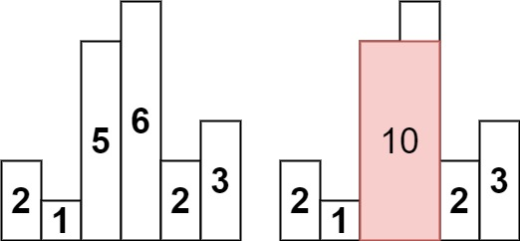

For the second test case, the line up is shown as well as the largest plot of land (for this test case there are two possible solutions):

